**A Mini-Project Report on**

**“EMPLOYEE MANAGEMENT SYSTEM”**

**Submitted By**

**Saad Ahmed**

**(1601-17-733-041)**

**&**

**Mohammed Safi Ammar**

**(1601-17-733-032)**



**Department Of Computer Science and Engineering**

**Chaitanya Bharathi Institute of Technology**

* Gandipet, Hyderabad, Telangana 500075

**ABSTRACT**

This software application stores all the employee’s information in a database. It is an application developed in C language and uses files to store the data. It contains employee information like name, age, salary. Only the administrator has access rights to change or modify any records. The main aim of this application is to reduce the human errors made in the manual system. A search can be made to find out details about the employee using his/her name. It is easy to update any employee details.

Employee information system is easy to use application which is created to manage the employee data. It is created to record the details of employees. This reduces dependency on the manual system which could create errors. There is a search feature which allows getting records of a specific employee. There are two views for this application, first is the administrator and the second is the employee view. The employee view enables employees to view their details.

The goal of this project is to design and develop an employee management system to fill existing gaps in the manual management of employees.

**INDEX:**

1. Introduction
   1. Motivation
   2. Employee Management System
2. Existing System
   1. Introduction to Existing System
   2. Disadvantages of Existing System
3. Proposed System
   1. Introduction to Proposed System
   2. Hardware and Software Requirement Analysis
   3. Modules
4. Design
   1. Block Diagram
   2. Flow Chart
5. Report

**INTRODUCTION**

**Motivation:**

The idea of this project came from the college attendance management system in which the attendance would be updated online and the students could view their results online as well.

But not all information of the student or staff is displayed on the website. So we thought of making a simple Employee Management System which can be used by small institutes or companies.

The idea was to design a program which could register a new employee with their information and be assigned to an Employee ID which the employees could use to search and see their details and their attendance status.

We decided to use C language because of our familiarity with the language. Though the program in C language won’t look as exciting without graphics, it will still give us a lot of insight into the subject of Data Structures which is a very essential in Computer Science Engineering.

**EMPLOYEE MANAGEMENT SYSTEM**

* The emplyee management system provides easy access for administrator and employees to change and view their employement information respectively.
* Employees can view their date of joining, employee I.D., years of experiencing etc. using this software.
* This software uses the simple C language to assign and store data.
* The aim is to remove the errors accounted by humans made in the manual information recording system.

**EXISTING SYSTEM:**

* The problem definition for designing the system is to maintain data of employee, to make easy controlling employees, to use technology for accurate and timely processing by fully privacy and full authority access.
* The objective of the project is to set up employee information system about status of employee and attendance of employee and monthly salary process and delivery.
* To eliminate or reduce as much as possible the hardships of existing system and avoid errors while entering data. In existing method employee management are employee record are maintain in records.

**Disadvantages Of Existing System**:

* Needs for extra manual effort .
* Existing system is a standalone process, normal employee cannot track their employee status .
* Less Accuracy.
* Time consuming process.

**PROPOSED SYSTEM:**

* This Employee management system is used for keeping the record of an employee in an organization such as school, college, universities, etc.
* Our project aims to design an employee management system which could effectively manage the information of employees at institutes, organisation, etc.
* This application maintains a database which has the details of the employees such as their name, age, and, salary.
* **Advantages Of Proposed System**:
* Helps in maintaining the computerized employee details .
* Can easily update employee details.
* More Efficient and reliable.
* Less time consuming and easy to use.

**MODULES:**

This Application contains two modules:

1. Admin

2. Search Employee Details

**ADMIN MODULE:**

* The admin module has the option to choose between registering a new employee, listing all the employees, modifying employee details, deleting an employee record or ssearching for employee details.
* Add Record: Enter name, age, basic salary.
* List Record: Lists all employees with their details.
* Modify Records: Allows to change employee details.
* Delete Records: Allows to delete a registered employee.
* Search: Allows to search for the details of an employee using name.

**USER MODULE:**

* A user can enter his/her name to check their details of employeement.

**HARDWARE & SOFTWARE REQUIREMENTS**

**1.Software Requirements:**

Operating system: Windows 7

Programming Language: C Language

IDE: Code::Blocks

**2. Hardware Requirements:**

Processor: Intel core i3

Memory size: 2 GB of RAM

Input: Mouse/Keyboard

**DESIGN:**

**Block Diagram:**

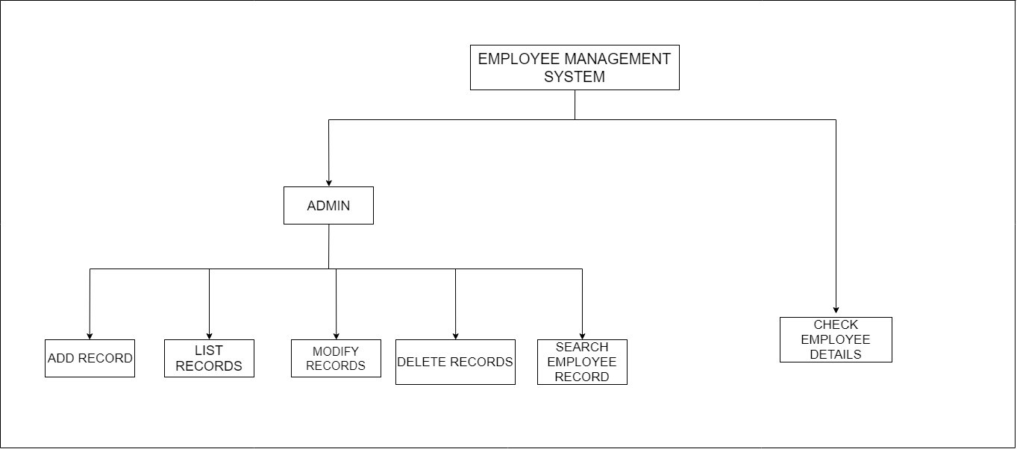

**Flow Chart:**

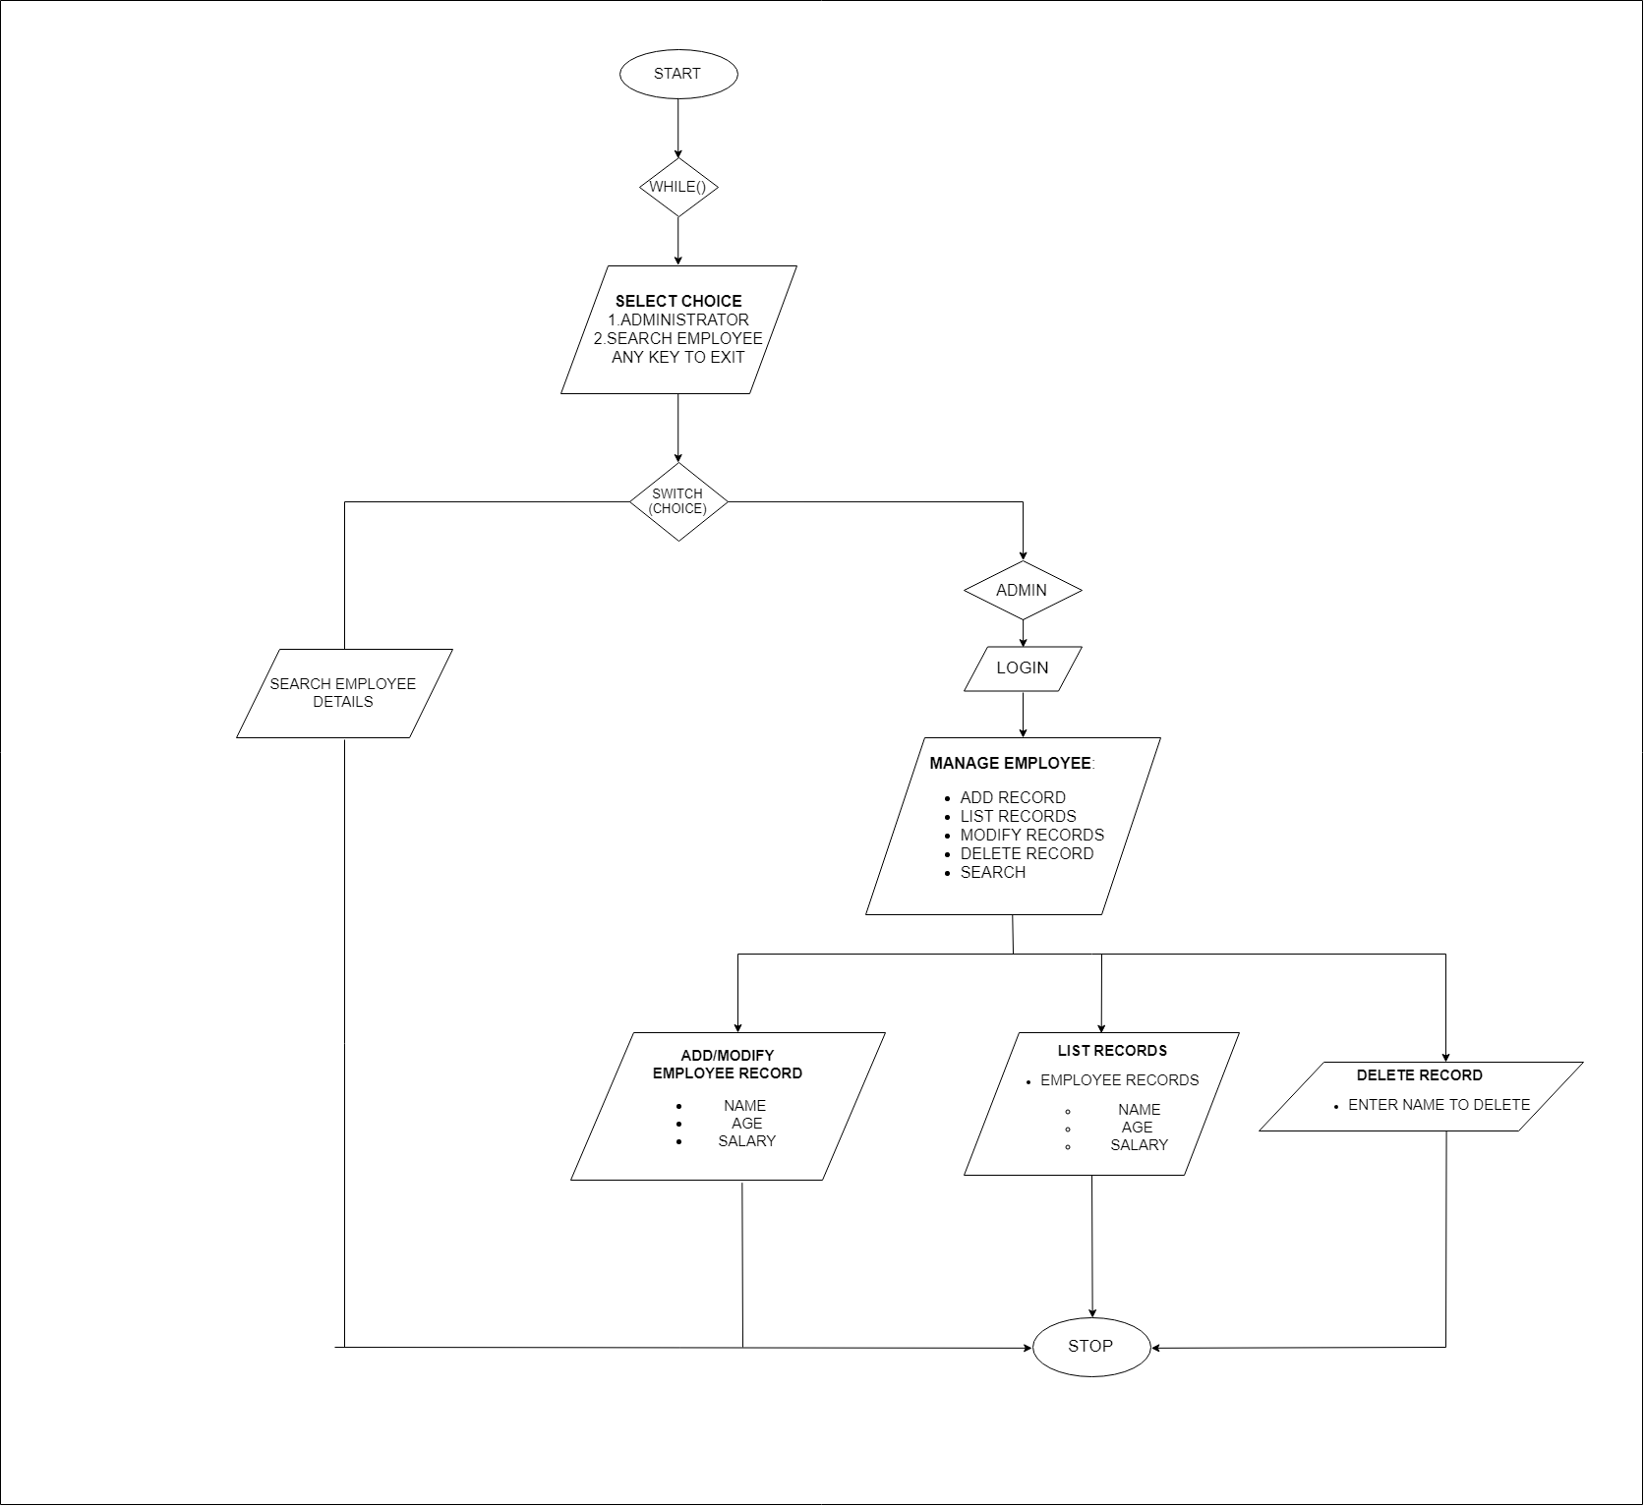

**CONCLUSION:**

The objective of this project was to implement an application for the maintaince of details and attendance of employees in a small institute or company. This objective has been accomplished in the corse of creating this project.

The program is definitely not perfect and there are many drawbacks but there is a lot of scopes of improvement to overcome them.These drawbacks include the resetting of attendance daily, any other person who has the employee ID of a person can view their details, and many more.